|  |
| --- |
| *solar power analysis* |

**INTRO**

The availability of energy has transformed the course of humanity over the last few centuries. Not only have new sources of energy been unlocked — first fossil fuels, followed by diversification to nuclear, hydropower, and now other renewable technologies — but also in the quantity we can produce and consume. Globally, primary energy consumption has increased nearly every year for at least half a century.

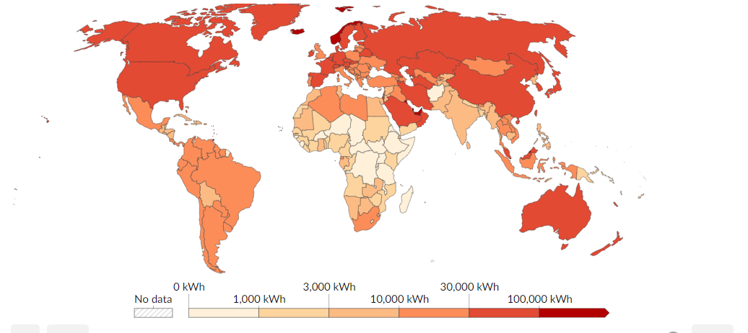

***Figure: Energy Consumption Per Head***

There is a drastic change in power generation and consumption demand since the Industrial Revolution. Solar energy is increasingly recognized as a vital component of our renewable energy sector. As we strive towards a sustainable future, it is critical to analyse understanding the factors that influence solar power generation is critical.

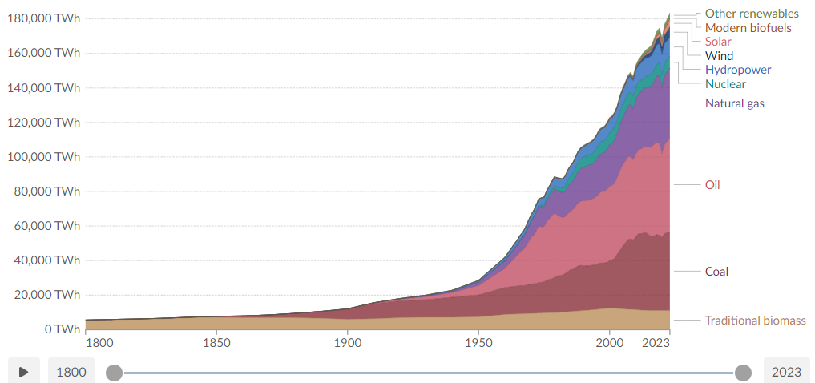

***Figure: Power Generation (TWh) By Different Modes***

**OBJECTIVE**

This project delves into the solar power generation data and corresponding weather data from two solar plants, Plant 1 and Plant 2. Both Plant contains their respective power generation data and weather sensor data.

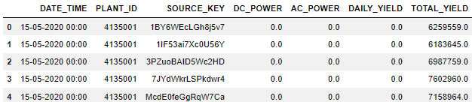

***Figure: Plant 1 Power Generation Data***

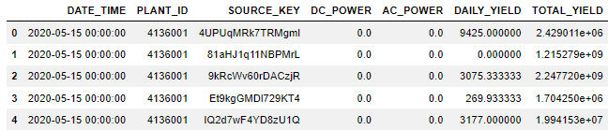

***Figure: Plant 2 Power Generation Data***

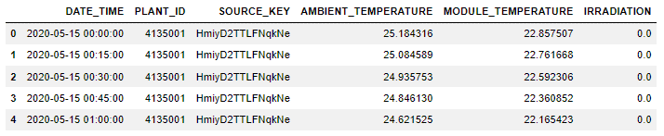

***Figure: Pant 1 Weather Sensor Data***

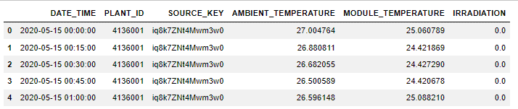

***Figure: Plant 2 Weather Sensor Data***

The objective of this project is to analyse solar power generation and weather data from two solar plants, Plant 1 and Plant 2, with the aim of gaining insights into the performance, efficiency, and resilience of solar energy systems. Ultimately, this project aims to contribute to the advancement of renewable energy technologies and facilitate the transition towards sustainable energy future.

Our goal is to uncover how weather conditions impact energy production, identify seasonal variations, and assess operational practices to optimize performance

**Impact of Weather Conditions on Solar Power Generation**

Weather plays a pivotal role in the performance of solar power plants. To grasp this relationship, we analysed data such as ambient temperature, module temperature, and irradiation levels.

**Temperature and Irradiation**

**Ambient Temperature:** High temperatures can reduce the efficiency of solar panels. Interestingly, our data showed that while higher ambient temperatures often correlated with increased irradiation, the efficiency gains from more sunlight were sometimes offset by the heat.

**Module Temperature:** Similar to ambient temperature, module temperature also affects performance. High module temperatures can reduce the efficiency of the photovoltaic cells.

**Irradiation:** Irradiation is the most direct factor affecting solar power generation. Higher irradiation levels usually result in increased power output.

Here’s a scatter plot showing the relationship between irradiation and power generation for Plant 1 and Plant 2:

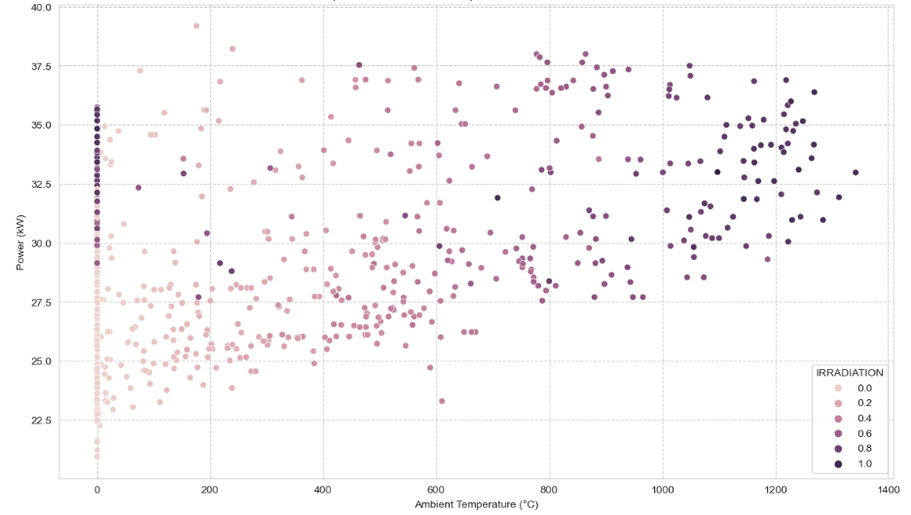

***Figure 1: Scatter Plot of Irradiation vs Power Generation***

The scatter lot vividly demonstrates a positive correlation between irradiation and power output, confirming the critical role of sunlight in solar energy generation. From the plot, we observe that higher ambient temperatures generally correlate with higher power generation, especially at higher irradiation levels. This indicates that both temperature and irradiation play significant roles in influencing the efficiency of solar power generation. The colour gradient from light pink to dark purple indicates increasing levels of irradiation.

**Seasonal Variations in Energy Production**

The performance of solar plants also varies across seasons due to changes in weather conditions. Our analysis focused on understanding these seasonal patterns to help optimize operational strategies.

**Seasonal Trends**

By examining the monthly average power generation, we observed significant seasonal trends. The summer months, characterized by longer days and higher irradiation levels, typically saw higher energy output. In contrast, the winter months exhibited lower power generation due to shorter days and reduced sunlight.

Below is a bar chart depicting the seasonal variation in energy production for Plant 1:

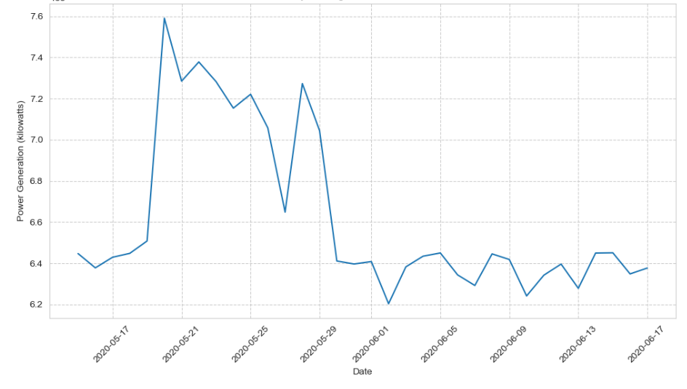

***Figure 2: Seasonal Variation in Energy Production***

This chart clearly shows how energy production peaks during the summer and dips in the winter, highlighting the importance of seasonal planning in solar power operations. The fluctuations in power generation over time, indicating variability in energy production. There are noticeable peaks and troughs, which could be due to changes in weather conditions or operational factors. This following visualization demonstrate the temporal patterns and identify the periods of high and low power generation.

**Operational Practices and Their Effectiveness**

To ensure optimal performance, solar plants must adopt effective operational practices. Our analysis compared the actual performance of the plants against potential performance, identifying areas for improvement.

**Maintenance and Efficiency**

Regular maintenance, such as cleaning panels to remove dust and debris, plays a crucial role in maintaining efficiency. Our findings suggest that periods of reduced maintenance coincide with dips in power output, underscoring the importance of a rigorous maintenance schedule.

**Predictive Analytics**

Leveraging predictive analytics can further enhance operational efficiency. For instance, integrating weather forecasts into operational planning allows for better anticipation of conditions that might affect power generation.

Below is a time series plot of power generation over the analysis period for both plants:

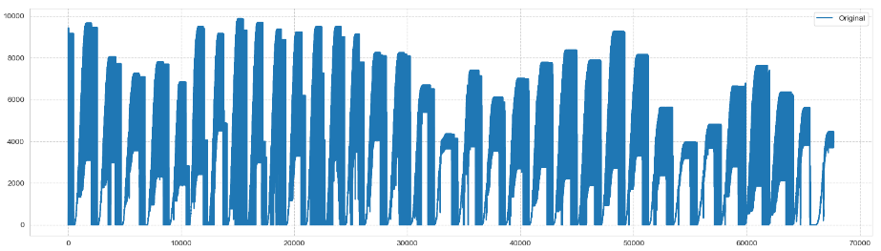

***Figure 3: Time Series of Power Generation for Plant 1 and Plant 2***

This time series plot provides a clear view of the fluctuations in power generation over time, revealing patterns that can inform better operational decisions. We can see regular patterns, with certain periods exhibiting higher power output. This visualization helps in identifying the consistency and reliability of the solar power plants, highlighting the periods of optimal performance and potential areas for improvement.

.**Insights and Recommendations**

My analysis provides several key insights and actionable recommendations:

**Enhance Weather Monitoring**

* Investing in advanced weather monitoring systems can help in better anticipating conditions and adjusting operations accordingly. Accurate weather data is crucial for maximizing power output and maintaining efficiency.
* **Weather Stations:** Install on-site weather stations that measure variables like solar radiation, temperature, wind speed, and humidity.
* **Satellite Data:** Utilize satellite imagery for broader area coverage and real-time updates.
* **Weather Forecasting Models:** Integrate with reliable weather forecasting services to anticipate changes in weather patterns.

**Optimize Maintenance Practices**

Implementing best practices for maintenance, such as regular cleaning and timely repairs, can significantly improve performance. As observed, cleaner panels lead to better efficiency and higher energy output. Therefore , timely focus on these key areas is required for optimization:

* **Regular Cleaning:** Establish a schedule for cleaning solar panels to remove dust, debris, and bird droppings that can reduce efficiency.
* **Timely Repairs:** Implement a proactive maintenance schedule to identify and address issues promptly, such as fixing faulty inverters or damaged panels.
* **Performance Monitoring:** Use monitoring systems to track performance metrics continually, allowing for early detection of inefficiencies.

**Adopt Advanced Technologies**

Integrating smart grid technologies and AI-based analytics can optimize energy distribution and enhance system resilience. These technologies can help in predicting performance, scheduling maintenance, and managing energy flow more effectively. Therefore, advancing the smart grid meters is essential.

* **Smart Meters:** Deploy smart meters to monitor energy consumption and production in real-time, facilitating efficient energy management.
* **Grid Automation:** Integrate automation technologies to optimize energy distribution and reduce transmission losses.
* **AI and Data Analytics:** Implement AI-driven analytics to predict energy demand, optimize grid operations, and enhance overall system reliability.

**Future Considerations**

Looking ahead, continuous improvement and innovation will be essential in advancing solar power technologies. By understanding and mitigating the impacts of weather conditions and optimizing operational practices, we can enhance the efficiency and sustainability of solar energy systems.

* **Energy Storage Solutions:** Develop or integrate storage solutions like batteries to store excess solar energy for use during periods of low generation or high demand.
* **Technological Advancements:** Embrace advancements in solar panel efficiency, such as next-generation materials and designs.
* **Regulatory and Policy Support:** Advocate for supportive policies and regulations that promote renewable energy adoption and grid modernization.

**Conclusion**

This report has underscored the pivotal influence of weather conditions on solar power generation and emphasized the necessity of implementing robust operational practices to optimize energy output. By leveraging advanced technologies and enhancing weather prediction and monitoring capabilities, significant improvements in the performance and efficiency of solar plants can be achieved.

The findings highlight the critical role of accurate weather data in mitigating operational risks and maximizing power generation. Implementing proactive maintenance practices, such as regular cleaning and timely repairs, is essential for sustaining peak efficiency. Moreover, integrating smart grid technologies and AI-based analytics offers opportunities to enhance grid resilience and optimize energy distribution.

Looking forward, this project sets the stage for future advancements in predictive modelling and data analytics, paving the way for more efficient and resilient solar energy systems. By continuing to innovate and adapt to evolving technological landscapes, stakeholders can further improve the sustainability and reliability of solar energy solutions.

This comprehensive approach not only addresses the current challenges but also positions solar energy as a viable and sustainable option for meeting future energy demands.